Proverbs 29:26
Many seek the ruler’s favour; but every man’s judgment cometh from the LORD.

The book of Proverbs, Ecclesiastes, and The Song of Solomon/Song of Songs
Proverbs 1:1
The proverbs of Solomon the son of David, king of Israel;

Ecclesiastes 1:1
The words of the Preacher, the son of David, king in Jerusalem.

Song of Solomon 1:1
The song of songs, which is Solomon’s.

II Samuel 12:24,25
And David comforted Bath–sheba his wife, and went in unto her, and lay with her: and she bare a son, and he called his name Solomon: and the LORD loved him. And he sent by the hand of Nathan the prophet; and he called his name Jedidiah, because of the LORD.

II Samuel 5:13,14 (I Chronicles 3:1-9)
And David took him more concubines and wives out of Jerusalem, after he was come from Hebron: and there were yet sons and daughters born to David. And these be the names of those that were born unto him in Jerusalem; Shammua, and Shobab, and Nathan, and Solomon,

Solomon (H8010) | שְׁלֹמֹה Shᵉlômôh, shel-o-mo'; from H7965; peaceful; Shelomah, David's successor | During Solomon’s reign Israel was “full of peace”. God gave them rest from their enemies and Judah and Israel dwelt safely.
Shalom (H7965)(Judges 6:24) | שָׁלוֹם shâlôwm, shaw-lome'; or שָׁלֹם shâlôm; from H7999; safe, i.e. (figuratively) well, happy, friendly; also (abstractly) welfare, i.e. health, prosperity, peace | A Hebrew greeting, based on the root for "completeness". Literally meaning "peace", shalom is used for both hello and goodbye.[6] A cognate with the Arabic-language salaam.
Jedidiah | יְדִידְיָה Yᵉdîydᵉyâh, yed-ee-deh-yaw'; from H3039 and H3050; beloved of Jah; Jedidejah, a name of Solomon | Jah is the shortened form of Jehovah

Solomon was the 3rd king to rule over Israel after his father David son of Jesse (Ruth 4:17), after Saul son of Kish/Cis (I Samuel 9:1,2/Acts 13:21) and his reign lasted 40 years (I Kings 11:42).

Description of the book of Proverbs
Proverbs 1:2-4
To know wisdom and instruction; to perceive the words of understanding; To receive the instruction of wisdom, justice, and judgment, and equity; To give subtilty to the simple, to the young man knowledge and discretion.

Solomon’s request and God’s blessing
I Kings 3:5-15
In Gibeon the LORD appeared to Solomon in a dream by night: and God said, Ask what I shall give thee. And Solomon said, Thou hast shewed unto thy servant David my father great mercy, according as he walked before thee in truth, and in righteousness, and in uprightness of heart with thee; and thou hast kept for him this great kindness, that thou hast given him a son to sit on his throne, as it is this day. And now, O LORD my God, thou hast made thy servant king instead of David my father: and I am but a little child: I know not how to go out or come in. And thy servant is in the midst of thy people which thou hast chosen, a great people, that cannot be numbered nor counted for multitude. Give therefore thy servant an understanding heart to judge thy people, that I may discern between good and bad: for who is able to judge this thy so great a people? And the speech pleased the Lord, that Solomon had asked this thing. And God said unto him, Because thou hast asked this thing, and hast not asked for thyself long life; neither hast asked riches for thyself, nor hast asked the life of thine enemies; but hast asked for thyself understanding to discern judgment; Behold, I have done according to thy words: lo, I have given thee a wise and an understanding heart; so that there was none like thee before thee, neither after thee shall any arise like unto thee. And I have also given thee that which thou hast not asked, both riches, and honour: so that there shall not be any among the kings like unto thee all thy days. And if thou wilt walk in my ways, to keep my statutes and my commandments, as thy father David did walk, then I will lengthen thy days. And Solomon awoke; and, behold, it was a dream. And he came to Jerusalem, and stood before the ark of the covenant of the LORD, and offered up burnt offerings, and offered peace offerings, and made a feast to all his servants.

David charges Solomon with the building of the first temple in Jerusalem
I Chronicles 22:5-13
And David said, Solomon my son is young and tender, and the house that is to be builded for the LORD must be exceeding magnifical, of fame and of glory throughout all countries: I will therefore now make preparation for it. So David prepared abundantly before his death. Then he called for Solomon his son, and charged him to build an house for the LORD God of Israel. And David said to Solomon, My son, as for me, it was in my mind to build an house unto the name of the LORD my God: But the word of the LORD came to me, saying, Thou hast shed blood abundantly, and hast made great wars: thou shalt not build an house unto my name, because thou hast shed much blood upon the earth in my sight. Behold, a son shall be born to thee, who shall be a man of rest; and I will give him rest from all his enemies round about: for his name shall be Solomon, and I will give peace and quietness unto Israel in his days. He shall build an house for my name; and he shall be my son, and I will be his father; and I will establish the throne of his kingdom over Israel for ever. Now, my son, the LORD be with thee; and prosper thou, and build the house of the LORD thy God, as he hath said of thee. Only the LORD give thee wisdom and understanding, and give thee charge concerning Israel, that thou mayest keep the law of the LORD thy God. Then shalt thou prosper, if thou takest heed to fulfil the statutes and judgments which the LORD charged Moses with concerning Israel: be strong, and of good courage; dread not, nor be dismayed.

Some of the resources for the building of the first temple
I Chronicles 22:14-19
Now, behold, in my trouble I have prepared for the house of the LORD an hundred thousand talents of gold, and a thousand thousand talents of silver; and of brass and iron without weight; for it is in abundance: timber also and stone have I prepared; and thou mayest add thereto. Moreover there are workmen with thee in abundance, hewers and workers of stone and timber, and all manner of cunning men for every manner of work. Of the gold, the silver, and the brass, and the iron, there is no number. Arise therefore, and be doing, and the LORD be with thee. David also commanded all the princes of Israel to help Solomon his son, saying, Is not the LORD your God with you? and hath he not given you rest on every side? for he hath given the inhabitants of the land into mine hand; and the land is subdued before the LORD, and before his people. Now set your heart and your soul to seek the LORD your God; arise therefore, and build ye the sanctuary of the LORD God, to bring the ark of the covenant of the LORD, and the holy vessels of God, into the house that is to be built to the name of the LORD.

100,000 talents of gold ~= 9,000,000lbs. (1 talent ~= 90lbs)
9,000,000lbs. = 144,000,000 ounces
Current gold price of $1,963.27/ounce = $282,710,880,000 (282 trillion USD)

1,000,000 talents of silver ~= 90,000,000lbs. (1 talent ~= 90lbs)
90,000,000lbs. = 1,440,000,000 ounces
Current silver price of $22.68/ounce = $32,659,200,000 (32 trillion USD)

Sacrifices at the dedication of the first temple after it’s completion
II Chronicles 7:1-5
Now when Solomon had made an end of praying, the fire came down from heaven, and consumed the burnt offering and the sacrifices; and the glory of the LORD filled the house. And the priests could not enter into the house of the LORD, because the glory of the LORD had filled the LORD’S house. And when all the children of Israel saw how the fire came down, and the glory of the LORD upon the house, they bowed themselves with their faces to the ground upon the pavement, and worshipped, and praised the LORD, saying, For he is good; for his mercy endureth for ever. Then the king and all the people offered sacrifices before the LORD. And king Solomon offered a sacrifice of twenty and two thousand oxen, and an hundred and twenty thousand sheep: so the king and all the people dedicated the house of God.
Solomon’s wisdom, wealth, and fame
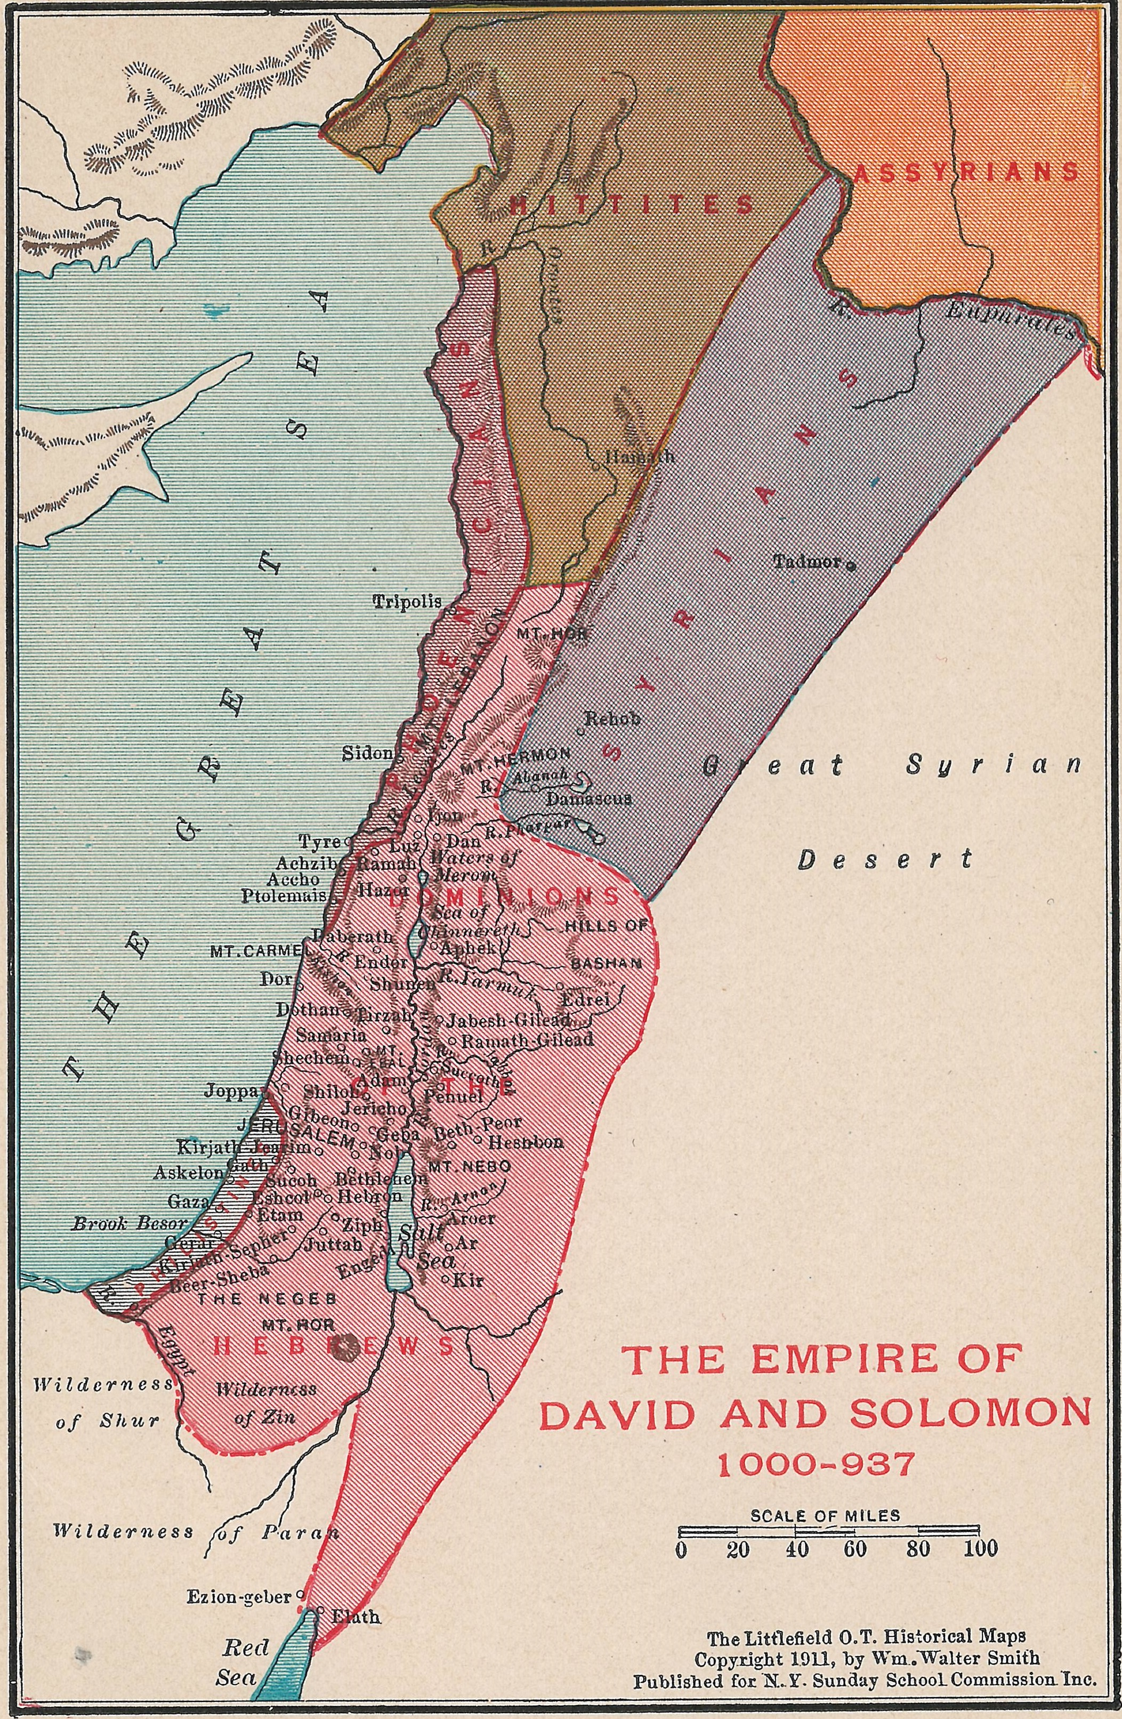
I Kings 4:20-34
Judah and Israel were many, as the sand which is by the sea in multitude, eating and drinking, and making merry. And Solomon reigned over all kingdoms from the river unto the land of the Philistines, and unto the border of Egypt: they brought presents, and served Solomon all the days of his life. And Solomon’s provision for one day was thirty measures of fine flour, and threescore measures of meal, Ten fat oxen, and twenty oxen out of the pastures, and an hundred sheep, beside harts, and roebucks, and fallowdeer, and fatted fowl. For he had dominion over all the region on this side the river, from Tiphsah even to Azzah, over all the kings on this side the river: and he had peace on all sides round about him. And Judah and Israel dwelt safely, every man under his vine and under his fig tree, from Dan even to Beer–sheba, all the days of Solomon. And Solomon had forty thousand stalls of horses for his chariots, and twelve thousand horsemen. And those officers provided victual for king Solomon, and for all that came unto king Solomon’s table, every man in his month: they lacked nothing. Barley also and straw for the horses and dromedaries brought they unto the place where the officers were, every man according to his charge. And God gave Solomon wisdom and understanding exceeding much, and largeness of heart, even as the sand that is on the sea shore. And Solomon’s wisdom excelled the wisdom of all the children of the east country, and all the wisdom of Egypt. For he was wiser than all men; than Ethan the Ezrahite, and Heman, and Chalcol, and Darda, the sons of Mahol: and his fame was in all nations round about. And he spake three thousand proverbs: and his songs were a thousand and five. And he spake of trees, from the cedar tree that is in Lebanon even unto the hyssop that springeth out of the wall: he spake also of beasts, and of fowl, and of creeping things, and of fishes. And there came of all people to hear the wisdom of Solomon, from all kings of the earth, which had heard of his wisdom.

I Kings 10 describes the visit of the Queen of Sheba and more of Solomon's vast wealth. Jesus also mentions her in Matthew 12:42 and Luke 11:31.

I Kings 10:23
So king Solomon exceeded all the kings of the earth for riches and for wisdom.

I Kings 11:3
And he had seven hundred wives, princesses, and three hundred concubines: and his wives turned away his heart.

Following Moses (from the exodus from Egypt to just before entering the promised land) and Joshua (entering, settling, and conquering the promised land) came a period in the children of Israel’s history referred to as “Judges” (Judges/I Samuel). During the Judges “period”, when the children of Israel did evil in the sight of the Lord they were delivered into the hands of their enemies. After a time appointed by the Lord, He then would raise up and enable a human “judge” to deliver the children of Israel from their enemies. From the period of Moses’ leadership to the end of the last judge Samuel there was no human king or human central government over Israel (~500yrs). The judges “period” ends when the people request a human king which we can read about beginning in I Samuel 8.

The elders of Israel reject God as their king and request and human king
I Samuel 8:1-22
And it came to pass, when Samuel was old, that he made his sons judges over Israel. Now the name of his firstborn was Joel; and the name of his second, Abiah: they were judges in Beer–sheba. And his sons walked not in his ways, but turned aside after lucre, and took bribes, and perverted judgment. Then all the elders of Israel gathered themselves together, and came to Samuel unto Ramah, And said unto him, Behold, thou art old, and thy sons walk not in thy ways: now make us a king to judge us like all the nations. But the thing displeased Samuel, when they said, Give us a king to judge us. And Samuel prayed unto the LORD. And the LORD said unto Samuel, Hearken unto the voice of the people in all that they say unto thee: for they have not rejected thee, but they have rejected me, that I should not reign over them. According to all the works which they have done since the day that I brought them up out of Egypt even unto this day, wherewith they have forsaken me, and served other gods, so do they also unto thee. Now therefore hearken unto their voice: howbeit yet protest solemnly unto them, and shew them the manner of the king that shall reign over them. And Samuel told all the words of the LORD unto the people that asked of him a king. And he said, This will be the manner of the king that shall reign over you: He will take your sons, and appoint them for himself, for his chariots, and to be his horsemen; and some shall run before his chariots. And he will appoint him captains over thousands, and captains over fifties; and will set them to ear his ground, and to reap his harvest, and to make his instruments of war, and instruments of his chariots. And he will take your daughters to be confectionaries, and to be cooks, and to be bakers. And he will take your fields, and your vineyards, and your oliveyards, even the best of them, and give them to his servants. And he will take the tenth of your seed, and of your vineyards, and give to his officers, and to his servants. And he will take your menservants, and your maidservants, and your goodliest young men, and your asses, and put them to his work. He will take the tenth of your sheep: and ye shall be his servants. And ye shall cry out in that day because of your king which ye shall have chosen you; and the LORD will not hear you in that day. Nevertheless the people refused to obey the voice of Samuel; and they said, Nay; but we will have a king over us; That we also may be like all the nations; and that our king may judge us, and go out before us, and fight our battles. And Samuel heard all the words of the people, and he rehearsed them in the ears of the LORD. And the LORD said to Samuel, Hearken unto their voice, and make them a king. And Samuel said unto the men of Israel, Go ye every man unto his city.

I Samuel 10:17-19
And Samuel called the people together unto the LORD to Mizpeh; And said unto the children of Israel, Thus saith the LORD God of Israel, I brought up Israel out of Egypt, and delivered you out of the hand of the Egyptians, and out of the hand of all kingdoms, and of them that oppressed you: And ye have this day rejected your God, who himself saved you out of all your adversities and your tribulations; and ye have said unto him, Nay, but set a king over us. Now therefore present yourselves before the LORD by your tribes, and by your thousands.

And so we learn from this that having a human king was not God’s will for Israel at that time. They are warned about it through the prophet and judge Samuel and they reject the warning. Then, God gives them what they requested by anointing Saul son of Kish as king over the children of Israel.
After Saul followed David and then his son Solomon as king of Israel. Solomon’s wisdom, wealth, and fame far exceeded that of any other king. People came from all around the world to hear the wisdom of Solomon. Many people sought the face of king Solomon during his 40 year reign. Try to imagine the wide variety of questions and petitions the different peoples would have. And, in the context of seeking the face of a ruler (for wisdom, help, or anything else), Proverbs 29:26 teaches us: our earthly rulers are not the final judge, God is.

Hebrews 9:27
And as it is appointed unto men once to die, but after this the judgment:

John 12:47,48
"And if any man hear my words, and believe not, I judge him not: for I came not to judge the world, but to save the world. He that rejecteth me, and receiveth not my words, hath one that judgeth him: the word that I have spoken, the same shall judge him in the last day."

Ecclesiastes 12:13,14
Let us hear the conclusion of the whole matter: Fear God, and keep his commandments: for this is the whole duty of man. For God shall bring every work into judgment, with every secret thing, whether it be good, or whether it be evil.

II Corinthians 5:9-11
Wherefore we labour, that, whether present or absent, we may be accepted of him. For we must all appear before the judgment seat of Christ; that every one may receive the things done in his body, according to that he hath done, whether it be good or bad. Knowing therefore the terror of the Lord, we persuade men; but we are made manifest unto God; and I trust also are made manifest in your consciences.

Revelation of John 20:11-15
And I saw a great white throne, and him that sat on it, from whose face the earth and the heaven fled away; and there was found no place for them. And I saw the dead, small and great, stand before God; and the books were opened: and another book was opened, which is the book of life: and the dead were judged out of those things which were written in the books, according to their works. And the sea gave up the dead which were in it; and death and hell delivered up the dead which were in them: and they were judged every man according to their works. And death and hell were cast into the lake of fire. This is the second death. And whosoever was not found written in the book of life was cast into the lake of fire.

In light of what we have learned from scripture, how do the two concepts in Proverbs 29:26 connect to each other?
but
Many seek the ruler’s favour | every man’s judgment cometh from the LORD

I Chronicles 16:10-12
Glory ye in his holy name: let the heart of them rejoice that seek the Lord. Seek the Lord and his strength, seek his face continually. Remember his marvellous works that he hath done, his wonders, and the judgments of his mouth;

Psalm 105:4
Seek the Lord, and his strength: seek his face evermore.

Psalms 119:57,58
Thou art my portion, O LORD: I have said that I would keep thy words. I intreated thy favour with my whole heart: be merciful unto me according to thy word.

Proverbs 2:6
For the Lord giveth wisdom: out of his mouth cometh knowledge and understanding.

Colossians 2:2,3
That their hearts might be comforted, being knit together in love, and unto all riches of the full assurance of understanding, to the acknowledgement of the mystery of God, and of the Father, and of Christ; In whom are hid all the treasures of wisdom and knowledge.

James 1:5
If any of you lack wisdom, let him ask of God, that giveth to all men liberally, and upbraideth not; and it shall be given him.

Genesis 18:14a
Is any thing too hard for the Lord?

Jerimiah 32:27
Behold, I am the Lord, the God of all flesh: is there any thing too hard for me?

Considering scripture carefully, judge within yourself: which do you think might work out better for you when you stand before the judgment seat of Christ?

Seeking the favour of a ruler | Seeking the favour of God
Seeking the wisdom of men | Seeking the wisdom of God
Seeking help from men | Seeking help from God
Seeking justice from men | Seeking justice from God
Seeking judgment from men | Seeking judgment from God
Seeking understanding from men | Seeking understanding from God

